K L UNIVERSITY
FRESHMAN ENGINEERING DEPARTMENT

A Project Based Lab Report On

MINI ARCADE GAME SUIT

SUBMITTED BY:
ID NUMBER NAME
2500032257 D. SHARANYA
2500032314 P. DHEERAJ
2500032354 R. MADHURI
2500030919 P. RUBEDHA

UNDER THE ESTEEMED GUIDANC OF
K . SAI SANDEEP
ASSISTANT PROFESSOR



KL UNIVERSITY
Green fields, Vaddeswaram – 522 502 Guntur Dt., AP, India.

DEPARTMENT OF BASIC ENGINEERING SCIENCES



CERTIFICATE

This is to certify that the project based laboratory report entitled “MINI ARCADE GAME SUITE” submitted by D.SHARANYA, P.DHEERAJ ,R.MADHURI, P.RUBEDHA MERI bearing Regd. No.2500032257, 2500032314, 2500032354, 2500032355 to the Department of COMPUTER SICENCE ENGINEERING , KL University in partial fulfillment of the requirements for the completion of a project based Laboratory in “PYTHON PROGRAMMING (25SC2007)” course in I B Tech II Semester, is a Bonafede record of the work carried out by him/her under my supervision during the academic year 2025 – 2026.

PROJECT SUPERVISOR HEAD OF THE DEPARTMENT Dr. SAI SANDEEP Dr. D. HARITHA

ACKNOWLEDGEMENTS

It is great pleasure for me to express my gratitude to our honorable President. Sri. Koneru Satyanarayana,
for giving the opportunity and platform with facilities in accomplishing the project-based laboratory
report.
I express sincere gratitude to our Director Dr. A. Jagdeesh for his administration towards our academic growth.
I express sincere gratitude to our Coordinator and HOD-BES Dr. D. Haritha for her leadership and constant motivation provided in successful completion of our academic semester. I record it as my privilege to deeply thank you for providing us with the efficient faculty and facilities to make our ideas into reality.
I express my sincere thanks to our project supervisor K .Sai Sandeep for his novel association of ideas, encouragement, appreciation, and intellectual zeal which motivated us to venture this project successfully.
Finally, we are pleased to acknowledge our indebtedness to all those who devoted themselves directly or indirectly to making this project a success.

Name: D.SHARANYA
P.DHEERAJ
R.MADHURI
P.RUBEDHA MERI
IDNO: 2500032257
2500032314
2500032354
2500032355

ABSTRACT

- This project is aimed at developing a Mini Arcade-Game Suite using Python for users who want to play simple games through a console-based application. The Mini Arcade-Game Suite is a project developed to provide a collection of small interactive games in a single program. This project helps users enjoy simple entertainment while also demonstrating basic programming concepts. In this system, users can choose different games from a menu and play them easily at any time. Some features provided to the users include a menu-driven interface, different mini games, user input options, and result display based on the user’s actions.
- The main objective of this project is to create a simple and interactive arcade system using Python programming. The Mini Arcade-Game Suite is a program that can be accessed by any user who runs the Python application on a computer. This application allows users to select and play games such as number guessing, simple logic-based games, and other small interactive activities. The system processes user inputs, generates random values where required, and displays the game results instantly. These games provide entertainment and also improve logical thinking and decision-making skills.
- This project demonstrates the use of Python concepts such as loops, conditional statements, functions, and random number generation. The program is designed in a structured way so that additional games can be added easily in the future. Overall, the Mini Arcade-Game Suite provides a simple and engaging platform for users while helping developers understand the fundamentals of Python programming.
Key Words: Mini Arcade Game, Python Programming, Console Application, Menu-Driven Program, Random Number Generation, User Interaction, Game Logic.

INDEX

S.NO | TITLE | PAGE NO
1 | Introduction | 6
2 | Aim of the Project | 7
2.1 | Advantages & Disadvantages | 8
2.2 | Future Implementation | 8
3 | Software & Hardware Details | 9
4 | Data Flow Diagram | 10
5 | Algorithm for each module | 11
6 | Implementation | 12-14
7 | Integration and System Testing | 15-17
8 | Conclusion | 18

INTRODUCTION
- The Mini Arcade-Game Suite is a simple console-based application developed using Python that provides a collection of small interactive games in a single program. The system uses a menu-driven interface where users can select and play different games according to their choice. It allows users to interact with the program through keyboard input and receive instant results based on their actions.
- The main purpose of this project is to demonstrate basic Python programming concepts such as loops, conditional statements, functions, and random number generation. The games are designed to be simple, engaging, and easy to understand, helping users improve their logical thinking while providing a fun gaming experience.

- Easy to learn and simple syntax
- Structured and readable programming language
- Supports efficient program development.
- Provides built-in modules like random for game logic
- Can run on different operating systems and computers.

AIM

The main aim of the Mini Arcade-Game Suite is to develop a simple console-based gaming application using Python. This system provides a collection of small interactive games that users can play through a menu-driven program. The project demonstrates how basic programming concepts such as loops, conditional statements, functions, and random number generation can be used to create simple games. It also helps users improve logical thinking and provides a fun and interactive experience.

This project aims to design a user-friendly game suite that allows players to select and play different games easily. It emphasizes modular programming and efficient code structure for better performance. The system also aims to improve user interaction through simple inputs and outputs. It provides a foundation for learning game development concepts. Thus, the project bridges the gap between learning and entertainment.

The modules in this project are –

- Game Selection Module – Displays a menu for users to choose different games and navigate easily within the system
- Game Logic Module – Contains the rules, conditions, and core functionality of each game implemented in the suite
- Score Management Module – Tracks, updates, and displays the scores of players for each game session
- User Interaction Module – Handles user inputs and provides appropriate outputs for smooth gameplay experience

ADVANTAGES
- Enhances logical thinking and problem-solving skills by engaging users in interactive gameplay and decision-making processes
- Provides entertainment through a collection of simple and fun games in a single platform, improving user engagement
- Easy to understand and implement using basic programming concepts, making it suitable for beginners and students
- Modular design allows easy addition of new games and features without affecting existing functionality
- Requires minimal system resources, making it lightweight and accessible on most computers

DISADVANTAGES
- Limited graphics and user interface compared to advanced or commercial arcade games, making it less visually appealing
- Lacks multiplayer or online features, restricting gameplay to a single user at a time.
- Basic functionality with fewer game options, which may reduce long-term user engagement.
- Requires manual input for gameplay, which may not be as interactive as modern gaming systems.
- No database integration for storing high scores or user progress permanently .

FUTURE IMPLEMENTATION
- Enhance the system by adding a graphical user interface using libraries like Tkinter or Pygame for better user experience.
- Introduce multiplayer and online gaming features to make the games more interactive and competitive.
- Add more advanced and diverse games to increase variety and user engagement.
- Implement a database system to store high scores, user profiles, and game history.
- Include sound effects, animations, and visual enhancements to make the games more attractive.

SYSTEM REQUIREMENTS

SOFTWARE REQUIREMENTS:
The major software requirements of the project are as follows:
Language: Python
Operating System: Windows 10 or above
Software Tools: Python IDLE / PyCharm / VS Code
Technical Requirements: Monitor, CPU, Keyboard

HARDWARE REQUIREMENTS:

The hardware requirements needed to run the software are as follows:
RAM: 4 GB or above
Processor: Intel i3 or higher

DATA FLOW DIAGRAM

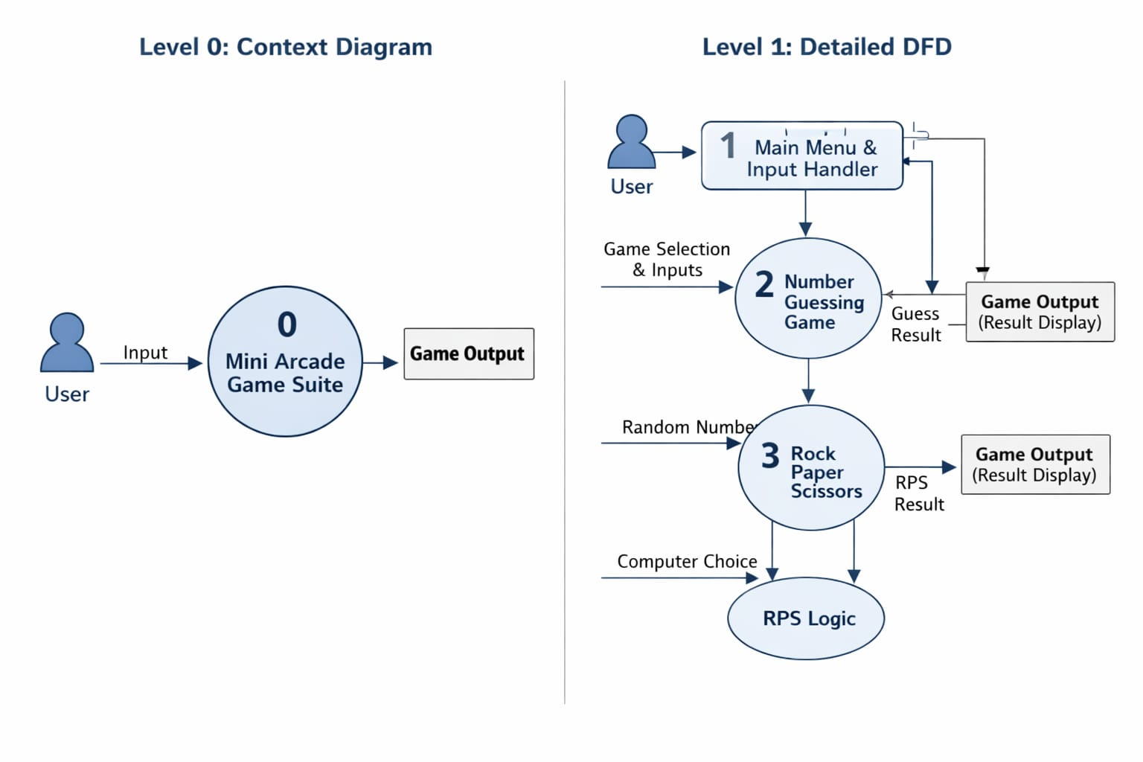

ALGORITHM
->Main Program Algorithm
Step 1: Start
Step 2: Display the menu (1. Number Guessing, 2. Rock Paper Scissors, 3. Exit)
Step 3: Read user choice
Step 4: If choice = '1', call Number Guessing Game
Step 5: Else if choice = '2', call Rock Paper Scissors
Step 6: Else if choice = '3', display "Thank you for playing" and stop
Step 7: Else display "Invalid choice"
Step 8: Repeat Step 2
->Algorithm for Number Guessing Game
Step 1: Start
Step 2: Generate a random number between 1 and 10
Step 3: Set attempts = 3
Step 4: Read user guess
Step 5: If guess == random number
Display "Correct! You win" and stop
Step 6: Else decrease attempts by 1
Step 7: Display remaining attempts
Step 8: If attempts > 0, go to Step 4
Step 9: Display "Game over" and the correct number
Step 10: Stop

IMPLEMENTATION

import random

def number_guessing_game():
print("\n--- Number Guessing Game ---")
number = random.randint(1, 10)
attempts = 3

while attempts > 0:
guess = int(input("Guess a number between 1 and 10: "))
if guess == number:
print("Correct! You win ")
return
else:
attempts -= 1
print("Wrong guess. Attempts left:", attempts)

print("Game over! The number was", number)

def rock_paper_scissors():
print("\n--- Rock Paper Scissors ---")
choices = ["rock", "paper", "scissors"]
computer = random.choice(choices)
user = input("Enter rock, paper, or scissors: ").lower()

if user not in choices:
print("Invalid choice")
return

print("Computer chose:", computer)

if user == computer:
print("It's a tie")
elif (user == "rock" and computer == "scissors") or \
(user == "paper" and computer == "rock") or \
(user == "scissors" and computer == "paper"):
print("You win")
else:
print("You lose")

def show_menu():
print("\nMINI ARCADE - GAME SUITE")
print("1. Number Guessing Game")
print("2. Rock Paper Scissors")
print("3. Exit")

def main():
while True:
show_menu()
choice = input("Enter your choice: ")

if choice == '1':
number_guessing_game()
elif choice == '2':
rock_paper_scissors()
elif choice == '3':
print("Thank you for playing")
break
else:
print("Invalid choice")

main()
INTEGRATION AND SYSTEM TESTING
OUTPUTS

Screen Shots:

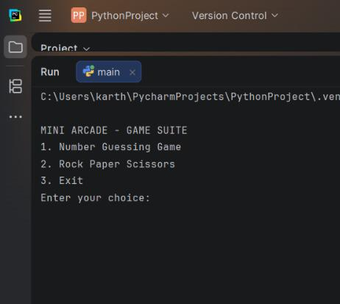

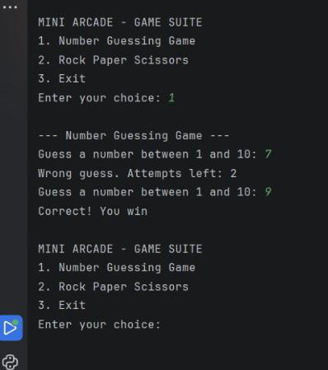

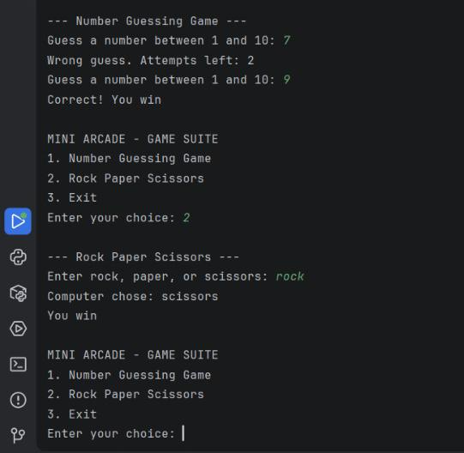
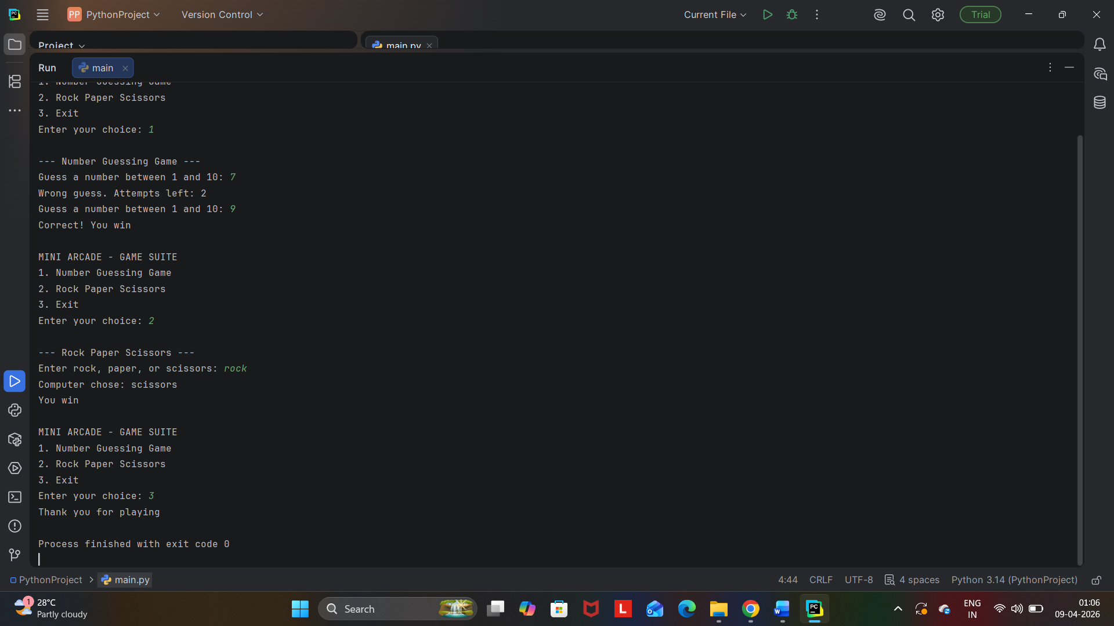

CONCLUSION

The Mini Arcade Game Suite successfully combines multiple simple games into a single platform, providing both entertainment and learning. It demonstrates fundamental programming concepts such as loops, conditions, and modular design. The system is easy to use and suitable for beginners. It enhances logical thinking and coding skills. Overall, it is an effective educational and fun project.

- This project highlights the importance of structured programming and user interaction in game development. It allows users to explore different games through a simple interface. The modular design makes the system flexible and easy to expand. It also helps in understanding how multiple functionalities can be integrated into one system. Thus, it serves as a strong base for future development.

- The Mini Arcade Game Suite proves that simple programming techniques can create engaging applications. It offers scope for further improvements such as graphics, sound, and multiplayer features. The project is highly useful for academic learning and practical implementation. With additional enhancements, it can evolve into a more advanced gaming system. Hence, it encourages creativity and innovation in programming.

